A

MINI PROJECT REPORT ON

“HOSPITAL MANAGEMENT SYSTEM”

Submitted By

STUDENT NAME | EXAM NO
VIJAY DEVKATE | T120538517
JITENDRA KUTE | T120538537
PRAJAKTA SALUNKE | T120538558
ABHIJEET SAWANT | T120538561

Guided By
Prof. Anil Kumar



DEPARTMENT OF INFORMATION TECHNOLOGY

DNYANGANGA COLLEGE OF ENGINEERING & RESEARCH

Narhe -PUNE - 411041

Zeal Education Society’s
Dnyanganga College of Engineering and Research, Pune 41

CERTIFICATE

This is to certify that JITENDRA KUTE,ABHIJEET SAWANT,VIJAY DEWAKATE, PRAJAKTA SALUNKE has successfully completed a mini project entitled “HOSPITAL MANAGEMENT SYSTEM” in the fulfillment of T.E. (IT Engineering) and this work has been carried out in my presence.

Prof. Anil Kumar Prof. B.R.Kanawade
Guide, Head,
Department of Information Technology Department of Information Technology

Dr.A.N.Gaikwad
Principal,
Dnyanganga College of Engineering
& researchPune 411 041

Place : Pune
Date : / /

Acknowledgement

It gives me immense pleasure in expressing my deepest sense of gratitude and sincere thanks towards my guide Prof. Anil Kumar whose precious suggestions and constructive guidance have been indispensable in the completion of this work. I would like to thank to my head of department Prof. B.R.Kanawade and all the members of IT Engineering Department of Dnyanganga College of Engineering and Research, Narhe, Pune-41 for encouragement and suggestions at my mini project work.

STUDENT NAME | EXAM NO
VIJAY DEVKATE | T120538517
JITENDRA KUTE | T120538537
PRAJAKTA SALUNKE | T120538558
ABHIJEET SAWANT | T120538561

1. INTRODUCTION

- This project is aimed to automate the hospital management system.
- The purpose of the project entitled as HOSPITAL MANAGEMENT SYSTEM is to computerize the Front Office Management of Hospital to develop software which is user friendly, simple, fast, and cost – effective.
- It deals with the collection of patient’s information etc. Traditionally, it was done manually.
- The main function of the system is to register and store patient details and doctor retrieve these details as and when required, and also to manipulate these details meaningfully.

- Need
1. Efficiently maintains the details about the patient
2. Simultaneously updates changes made to any data, item in the entire data
base.
3. It is faster than manual system

- Until recently, the common functions of a Hospital management system are to support the maintenance of Patient and study information relating to:
- Add Patient details
- Add Patient Bill
- Edit Patient details
- View Patient details
- View Patient Bill
- Search Patient details
- search Bill details
- Delete Patient details
- Delete Bill details

2. Hardware and Software Requirments
HARDWARE SPECIFICATION:
Software Requirements
Operating System : Windows XP/7/8
Programming Language : JAVA
Database : MONGO
Hardware Requirements
Processor : Pentium IV
Hard Disk : 40GB or more
RAM :512MB or more

Relational Database
01)Patient Info:-
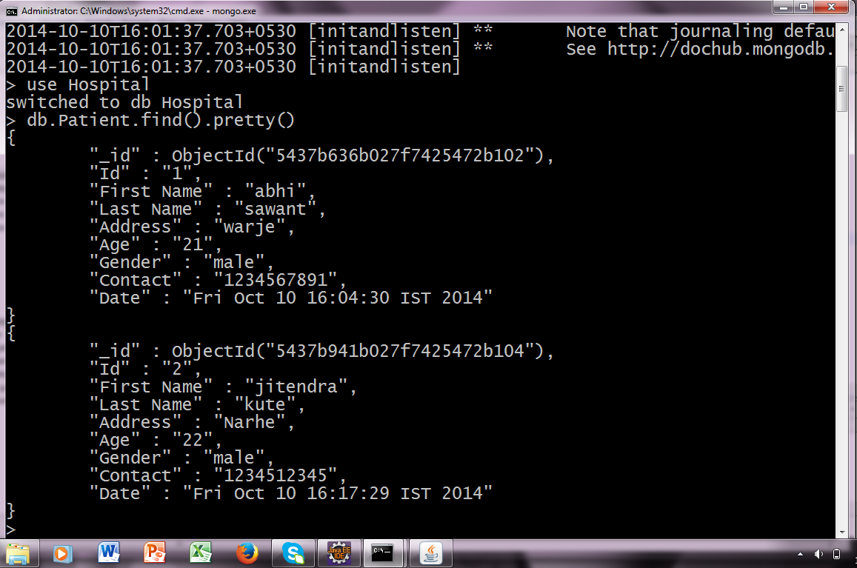

02) Patient Bill :-

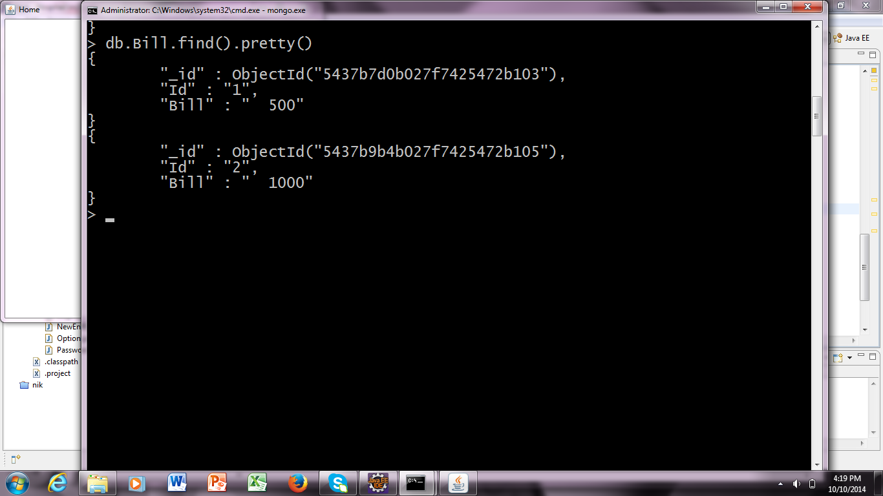

Graphical User Interface

01)adminlogin
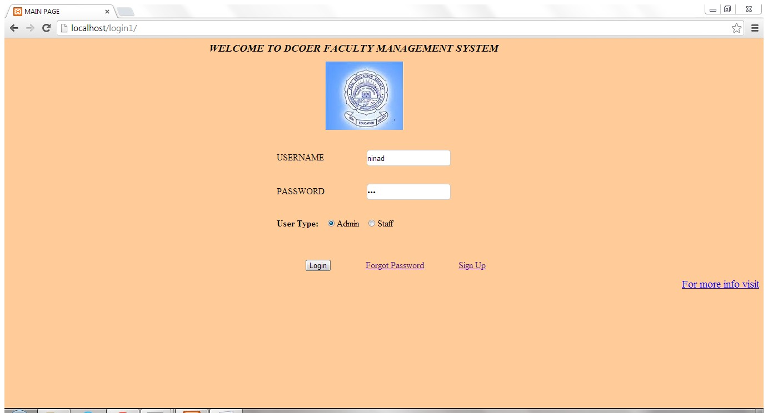

03) Add Patient :

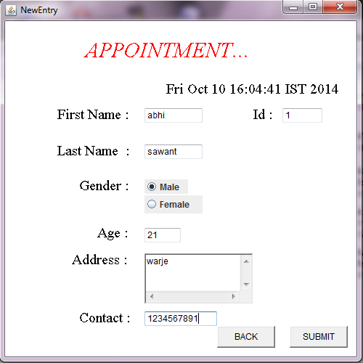

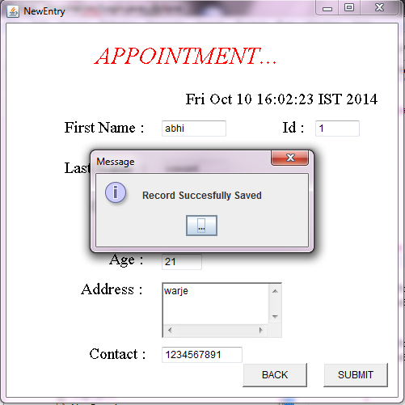

04) Add Bill :-

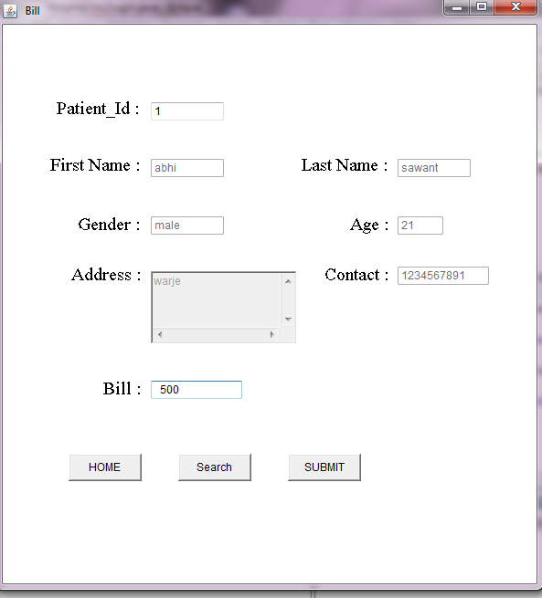

5) For Perform Search & Delete Operation:-

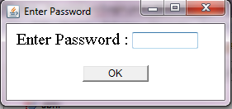

05)Faculty Feedback
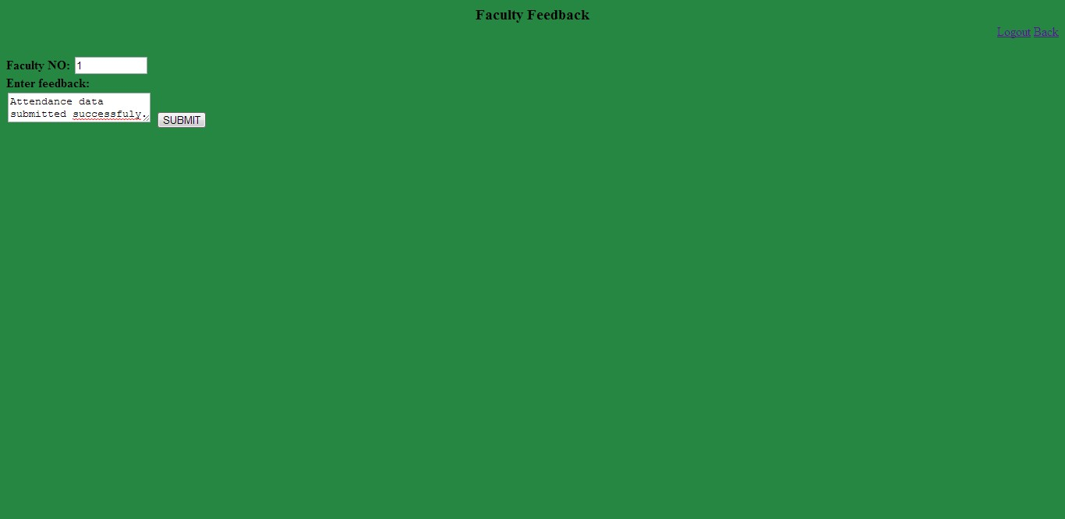

Entity Relationship Diagram:-

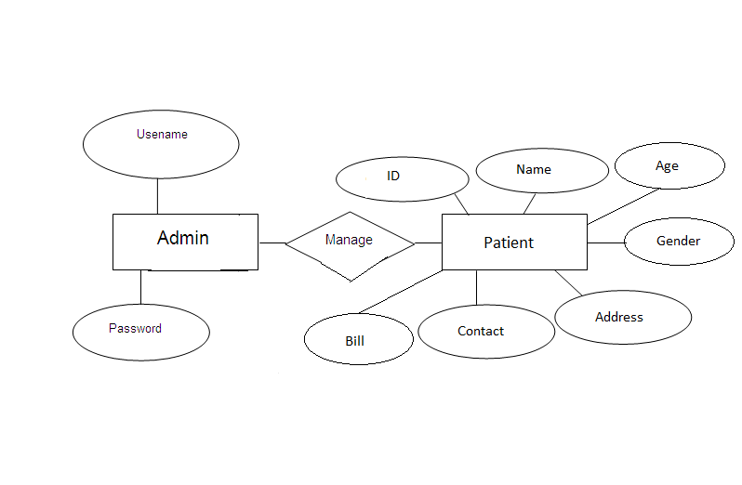

Source Code:-

01) Login.java

import java.awt.Button;
import java.awt.Checkbox;
import java.awt.CheckboxGroup;
import java.awt.Choice;
import java.awt.FlowLayout;
import java.awt.Font;
import java.awt.Frame;
import java.awt.Graphics;
import java.awt.Label;
import java.awt.TextArea;
import java.awt.TextField;
import java.awt.event.ActionEvent;
import java.awt.event.ActionListener;
import java.awt.event.TextEvent;
import java.awt.event.TextListener;
import java.awt.event.WindowAdapter;
import java.awt.event.WindowEvent;
import java.awt.event.WindowStateListener;
import java.util.Calendar;
import java.util.Date;
import java.util.GregorianCalendar;

import javax.swing.*;

public class Login extends Frame implements ActionListener
{
Button login;
JLabel label;
TextField field;
Login()
{
super("Login Page");
setLayout(null);
label=new JLabel();
login=new Button(" Login ");
field=new TextField(30);
field.setEchoChar('*');

login.setBounds(200,430,100,30);
field.setBounds(220,355,130,20);

add(login);
add(field);
login.addActionListener(this);

setSize(500,500);
setVisible(true);

addWindowListener(new WindowAdapter() {
public void windowClosing(WindowEvent we) {
dispose();
}
});

}

public static void main(String args[]) {
Login obj=new Login();

}

public void actionPerformed(ActionEvent arg0) {
boolean check = false;
String password;
String pass="Admin123";
password = field.getText();
if(password.equals(pass))
{
Home newentry =new Home();
this.dispose();
}
else
{
JOptionPane.showMessageDialog( this, "Incorrect Password");
field.setText(null);
}

}

public void paint(Graphics g) {
Font font=new Font("TimesRoman",Font.BOLD,20);
g.setFont(font);
g.drawString("Password : ",120,370);

Font font1=new Font("TimesRoman",Font.BOLD,40);
g.setFont(font1);
g.drawString("OM HOSPITAL",120,80);

}

}

2) Home.java

import java.awt.Button;
import java.awt.Font;
import java.awt.Frame;
import java.awt.Graphics;
import java.awt.Label;
import java.awt.event.ActionEvent;
import java.awt.event.ActionListener;
import java.awt.event.WindowAdapter;
import java.awt.event.WindowEvent;
import java.net.UnknownHostException;

public class Home extends Frame implements ActionListener{

Button newentry,bill,logout,option;

Home()
{
super("Home");
setLayout(null);

newentry = new Button(" New Entry ");
bill = new Button(" Bill Amount ");
logout = new Button(" Log Out ");
option =new Button(" Option ");

newentry.setBounds(210, 170, 90, 30);
bill.setBounds(210, 240, 90, 30);
logout.setBounds(210, 380, 90, 30);
option.setBounds(210, 310, 90, 30);

newentry.addActionListener(this);
bill.addActionListener(this);
logout.addActionListener(this);
option.addActionListener(this);

add(newentry);
add(bill);
add(logout);
add(option);

setSize(500,500);
setVisible(true);

addWindowListener(new WindowAdapter() {
public void windowClosing(WindowEvent we) {
dispose();
}
});
}

public static void main(String[] args) {
Home home=new Home();

}

public void paint(Graphics g) {
Font font=new Font("TimesRoman",Font.BOLD,30);
g.setFont(font);

g.drawString(" WELCOME ",170,100);
}

public void actionPerformed(ActionEvent e) {

if(e.getSource()== newentry)
{

NewEntry login=new NewEntry();
this.dispose();

}
else if(e.getSource()==bill)
{
Bill b=new Bill();
this.dispose();
}
else if(e.getSource()==option)
{
Password p=new Password();
this.dispose();
}
else
{
Login home=new Login();
this.dispose();
}

}

}

3) NewEntry.java

import java.awt.Button;
import java.awt.Checkbox;
import java.awt.CheckboxGroup;
import java.awt.Color;
import java.awt.Font;
import java.awt.Frame;
import java.awt.Graphics;
import java.awt.Label;
import java.awt.TextArea;
import java.awt.TextField;
import java.awt.event.ActionEvent;
import java.awt.event.ActionListener;
import java.awt.event.WindowAdapter;
import java.awt.event.WindowEvent;
import java.net.UnknownHostException;
import java.util.GregorianCalendar;

import javax.swing.ButtonGroup;
import javax.swing.JOptionPane;
import javax.swing.JRadioButton;

import com.mongodb.*;

public class NewEntry extends Frame implements ActionListener
{
private static final Color RED =null;
Label g;
String s;
Button submit,back;
TextField fname,lname,cno,age;
TextField id;
ButtonGroup group;
JRadioButton male,female;
TextArea area;

NewEntry()
{
super("NewEntry");
setLayout(null);
Frame frame =new Frame();
submit = new Button(" SUBMIT ");
back = new Button(" BACK ");
area = new TextArea("",3,100,0);
fname = new TextField();
lname = new TextField();
age = new TextField();
cno = new TextField();
id = new TextField();
g = new Label();
group =new ButtonGroup();
male=new JRadioButton("Male");
female=new JRadioButton("Female");
group.add(male);
group.add(female);
male.setBounds(200, 248, 60, 20);
female.setBounds(200,270 , 80,25);
area.setBounds(200, 350, 150, 70);
fname.setBounds(200, 150, 80, 20);
lname.setBounds(200, 200, 80, 20);
age.setBounds(200, 315, 50, 20);
cno.setBounds(200,430,100,20);
g.setBounds(200,460,20,20);
id.setBounds(390,150, 55, 20);

submit.setBounds(400, 450, 80, 30);
submit.addActionListener(this);

back.setBounds(300, 450, 80, 30);
back.addActionListener(this);

add(submit);
add(back);
add(area);
add(male);
add(female);
add(id);
add(fname);
add(lname);
add(age);
add(cno);
add(g);
try{

int a=assign_id();
id.setText(String.valueOf(a));
}catch (Exception e) {
// TODO: handle exception
}
//id.disable();
setSize(500,500);
setVisible(true);

addWindowListener(new WindowAdapter() {
public void windowClosing(WindowEvent we) {
dispose();

}
});

}
public void saveData() throws Exception
{
MongoClient clientobj = new MongoClient("localhost",27017);
DB db = clientobj.getDB("Hospital");
DBCollection Patient = db.getCollection("Patient");
BasicDBObject query = new BasicDBObject();
query.append("Id",id.getText());
query.append("First Name",fname.getText());
query.append("Last Name",lname.getText());
query.append("Address",area.getText());
query.append("Age",age.getText());

String sex;
if(male.isSelected())
{
sex = "male";
}
else
{
sex = "female";
}
query.append("Gender",sex);
query.append("Contact",cno.getText());
GregorianCalendar g1=new GregorianCalendar();
String s=g1.getTime().toString();
query.append("Date",s);
Patient.insert(query);
}

public int assign_id()
{

try {
int val=0;
MongoClient clientobj = new MongoClient("localhost",27017);
DB db = clientobj.getDB("Hospital");
DBCollection Patient = db.getCollection("Patient");
BasicDBObject query = new BasicDBObject();

query.put("Id", -1);
DBCursor Cursor = Patient.find().sort(query).limit(1);
DBObject x=Cursor.next();
val =Integer.parseInt((String)x.get("Id"));
return val+1;

}
catch (UnknownHostException e)
{
System.out.println(e);
return 1;
}

}

public static void main(String[] args)
{
NewEntry obj = new NewEntry();
}

public void actionPerformed(ActionEvent e)
{

if(e.getSource()== submit)
{

try {
saveData();
}
catch (Exception e1)
{
System.out.println(e1);
}
JOptionPane.showMessageDialog(this,"Record Succesfully Saved");
fname.setText(null);
lname.setText(null);
cno.setText(null);
age.setText(null);
area.setText(null);
int a=assign_id();
id.setText(String.valueOf(a));
}
else
{
Home home=new Home();
this.dispose();
}

}

public void paint(Graphics g)
{
Font font=new Font("TimesRoman",Font.PLAIN,20);
g.setFont(font);
setBackground(Color.white);
g.drawString("First Name : ",80, 165);
g.drawString("Last Name : ",80, 215);
g.drawString("Address : ",100,365);
g.drawString("Contact : ",110,445);
g.drawString("Gender : ",110, 263);
g.drawString("Age : ",135,328);
g.drawString("Id : ",350,165);

GregorianCalendar g1=new GregorianCalendar();
String s=g1.getTime().toString();
g.drawString(s,230 ,130 );

Font font1=new Font("TimesRoman",Font.ITALIC,30);
g.setFont(font1);
g.setColor(Color.red);
g.drawString("APPOINTMENT... ",120,80);

}
}

4) Bill.java

import java.awt.Button;
import java.awt.Checkbox;
import java.awt.CheckboxGroup;
import java.awt.Color;
import java.awt.Font;
import java.awt.Frame;
import java.awt.Graphics;
import java.awt.Label;
import java.awt.MenuComponent;
import java.awt.TextArea;
import java.awt.TextField;
import java.awt.event.ActionEvent;
import java.awt.event.ActionListener;
import java.awt.event.WindowAdapter;
import java.awt.event.WindowEvent;
import java.awt.event.WindowListener;
import java.net.UnknownHostException;
import java.text.FieldPosition;

import javax.swing.JOptionPane;

import com.mongodb.*;

public class Bill extends Frame implements ActionListener {

Label g,j;
Button submit,search,home,del;
TextField fname,lname,cno,age,id,bill,gender;
TextArea addr;

Bill()
{
super(" Bill");
setLayout(null);

search = new Button(" Search ");
submit = new Button(" SUBMIT ");
del = new Button(" DELETE ");
home = new Button(" HOME ");
addr = new TextArea("",3,100,0);
id = new TextField();
fname = new TextField(" ");
lname = new TextField(" ");
age = new TextField(" ");
cno = new TextField(" ");
g = new Label(" ");
j = new Label(" ");
bill= new TextField(" ");
gender= new TextField(" ");

id.setBounds(170, 115, 80, 20);
addr.setBounds(170, 300, 160, 80);
fname.setBounds(170, 177, 80, 20);
lname.setBounds(440, 177, 80, 20);
age.setBounds(440, 240, 50, 20);
cno.setBounds(440,295,100,20);
gender.setBounds(170,240,80,20);
g.setBounds(200,540,200,20);
j.setBounds(263,570,200,20);
bill.setBounds(170,420, 100, 20);

addr.disable();
age.disable();
fname.disable();
lname.disable();
gender.disable();
cno.disable();

addWindowListener(new WindowAdapter() {
public void windowClosing(WindowEvent we) {
dispose();
}
});
submit.setBounds(320, 500, 80, 30);
submit.addActionListener(this);

home.setBounds(80, 500, 80, 30);
home.addActionListener(this);

search.setBounds(200, 500, 80, 30);
search.addActionListener(this);

// del.setBounds(450, 500, 80, 30);
// del.addActionListener(this);

add(submit);
add(home);
add(addr);
add(id);
add(fname);
add(lname);
add(age);
add(cno);
add(g);
add(j);
add(bill);
add(gender);
add(search);
//add(del);
setSize(600,650);
setVisible(true);

}
public void Retrieve() throws Exception
{
String a=id.getText();
MongoClient clientobj = new MongoClient("localhost",27017);
DB db = clientobj.getDB("Hospital");
DBCollection Patient = db.getCollection("Patient");
DBObject query =new BasicDBObject();
query.put("Id",a);

DBCursor Cursor = Patient.find(query);

query = Cursor.next();

Object name = query.get("First Name");
fname.setText((String)name);
Object gender1 = query.get("Gender");
gender.setText((String)gender1);
Object lsname = query.get("Last Name");
lname.setText((String)lsname);
Object add1 = query.get("Address");
addr.setText((String)add1);
Object con1 = query.get("Contact");
cno.setText((String)con1);
Object age1 = query.get("Age");
age.setText((String)age1);

}

public void saveData() throws Exception
{
MongoClient clientobj = new MongoClient("localhost",27017);
DB db = clientobj.getDB("Hospital");
DBCollection Bill = db.getCollection("Bill");
BasicDBObject query = new BasicDBObject();
query.append("Id",id.getText());
query.append("Bill",bill.getText());
Bill.insert(query);
}

public static void main(String[] args) {

Bill bill=new Bill();
}

public void actionPerformed(ActionEvent e) {

if(e.getSource()==submit)
{

try {
saveData();
} catch (Exception e1) {
System.out.println(e1);
};
fname.setText(null);
lname.setText(null);
cno.setText(null);
age.setText(null);
id.setText(null);
bill.setText(null);
addr.setText(null);
gender.setText(null);
JOptionPane.showMessageDialog(this,"Record Succesfully Saved");
}
else if(e.getSource()==search)
{

try {
Retrieve();
} catch (Exception e1) {

fname.setText(null);
lname.setText(null);
cno.setText(null);
age.setText(null);
id.setText(null);
bill.setText(null);
addr.setText(null);
gender.setText(null);
JOptionPane.showMessageDialog(this,"No Record Found");
System.out.println(e1);
}
}
else
{
Home home1=new Home();
this.dispose();
}

}

public void paint(Graphics g) {
Font font=new Font("TimesRoman",Font.PLAIN,20);
g.setFont(font);
setBackground(Color.white);
g.drawString(" Patient_Id : ",62,128);
g.drawString("First Name : ",60, 190);
g.drawString("Last Name : ",335, 190);
g.drawString("Address : ",83,310);
g.drawString("Contact : ",360,310);
g.drawString("Gender : ",90, 255);
g.drawString("Age : ",388,255);
g.drawString("Bill : ",118,435);

}
}

5) Option.java

import java.awt.Button;
import java.awt.Color;
import java.awt.Font;
import java.awt.Frame;
import java.awt.Graphics;
import java.awt.Label;
import java.awt.TextArea;
import java.awt.TextField;
import java.awt.event.ActionEvent;
import java.awt.event.ActionListener;
import java.awt.event.WindowAdapter;
import java.awt.event.WindowEvent;

import javax.swing.JOptionPane;

import com.mongodb.BasicDBObject;
import com.mongodb.DB;
import com.mongodb.DBCollection;
import com.mongodb.DBCursor;
import com.mongodb.DBObject;
import com.mongodb.MongoClient;

public class Option extends Frame implements ActionListener
{

Button search,home,delete;
TextField fname,lname,cno,age,id,bill,gender;
TextArea addr;
public Option()
{

super(" Option ");
setLayout(null);

search = new Button(" Search ");
delete = new Button(" DELETE ");
home = new Button(" HOME ");
addr = new TextArea("",3,100,0);
id = new TextField();
fname = new TextField(" ");
lname = new TextField(" ");
age = new TextField(" ");
cno = new TextField(" ");
bill= new TextField(" ");
gender= new TextField(" ");

id.setBounds(170, 115, 80, 20);
addr.setBounds(170, 300, 160, 80);
fname.setBounds(170, 177, 80, 20);
lname.setBounds(440, 177, 80, 20);
age.setBounds(440, 240, 50, 20);
cno.setBounds(440,295,100,20);
gender.setBounds(170,240,80,20);
bill.setBounds(170,420, 100, 20);

addr.disable();
age.disable();
fname.disable();
lname.disable();
gender.disable();
cno.disable();
bill.disable();

addWindowListener(new WindowAdapter()
{
public void windowClosing(WindowEvent we)
{
dispose();
}
});

home.setBounds(80, 500, 80, 30);
home.addActionListener(this);

search.setBounds(200, 500, 80, 30);
search.addActionListener(this);

delete.setBounds(320, 500, 80, 30);
delete.addActionListener(this);

add(home);
add(addr);
add(id);
add(fname);
add(lname);
add(age);
add(cno);
add(bill);
add(gender);
add(search);
add(delete);
setSize(600,650);
setVisible(true);

}

public void delete() throws Exception
{
String a=id.getText();
MongoClient clientobj = new MongoClient("localhost",27017);
DB db = clientobj.getDB("Hospital");
DBCollection Patient = db.getCollection("Patient");
DBObject query =new BasicDBObject();
query.put("Id",a);
DBCursor Cursor = Patient.find(query);
query = Cursor.next();
Patient.remove(query);
DBCollection Bill = db.getCollection("Bill");
DBObject query1 =new BasicDBObject();
query1.put("Id",a);
Bill.remove(query1);

fname.setText(null);
lname.setText(null);
cno.setText(null);
age.setText(null);
id.setText(null);
bill.setText(null);
addr.setText(null);
gender.setText(null);
JOptionPane.showMessageDialog( this, "Record Successfully Deleted");

}

public void Retrieve() throws Exception
{
String a=id.getText();
MongoClient clientobj = new MongoClient("localhost",27017);
DB db = clientobj.getDB("Hospital");
DBCollection Patient = db.getCollection("Patient");
DBObject query =new BasicDBObject();
query.put("Id",a);

DBCursor Cursor = Patient.find(query);

query = Cursor.next();

Object name = query.get("First Name");
fname.setText((String)name);
Object gender1 = query.get("Gender");
gender.setText((String)gender1);
Object lsname = query.get("Last Name");
lname.setText((String)lsname);
Object add1 = query.get("Address");
addr.setText((String)add1);
Object con1 = query.get("Contact");
cno.setText((String)con1);
Object age1 = query.get("Age");
age.setText((String)age1);

DBCollection Bill = db.getCollection("Bill");
DBObject query1 =new BasicDBObject();
query1.put("Id",a);
DBCursor Cursor1 = Bill.find(query1);
query1 = Cursor1.next();
Object name1 = query1.get("Bill");
bill.setText((String)name1);

}

public static void main(String[] args)
{

Option op=new Option();
}

public void actionPerformed(ActionEvent e)
{

if(e.getSource()==search)
{

try
{
Retrieve();
}
catch (Exception e1)
{
fname.setText(null);
lname.setText(null);
cno.setText(null);
age.setText(null);
id.setText(null);
bill.setText(null);
addr.setText(null);
gender.setText(null);
JOptionPane.showMessageDialog(this,"No Record Found");
System.out.println(e1);
}
}
else if(e.getSource()==delete)
{
try
{
delete();
}
catch (Exception e1)
{
JOptionPane.showMessageDialog(this,"No Record Found");
System.out.println(e1);
}
}
else
{
Home home1=new Home();
this.dispose();
}

}

public void paint(Graphics g)
{
Font font=new Font("TimesRoman",Font.PLAIN,20);
g.setFont(font);
setBackground(Color.white);
g.drawString(" Patient_Id : ",62,128);
g.drawString("First Name : ",60, 190);
g.drawString("Last Name : ",335, 190);
g.drawString("Address : ",83,310);
g.drawString("Contact : ",360,310);
g.drawString("Gender : ",90, 255);
g.drawString("Age : ",388,255);
g.drawString("Bill : ",118,435);

}
}

6) Password.java

import java.awt.Button;
import java.awt.Font;
import java.awt.Frame;
import java.awt.Graphics;
import java.awt.TextField;
import java.awt.event.ActionEvent;
import java.awt.event.ActionListener;

import javax.swing.JOptionPane;

import com.mongodb.BasicDBObject;
import com.mongodb.DB;
import com.mongodb.DBCollection;
import com.mongodb.DBCursor;
import com.mongodb.DBObject;
import com.mongodb.MongoClient;

public class Password extends Frame implements ActionListener
{
TextField pass, gender,fname,lname,cno,age,id,bill,addr;
Button ok;
Password()
{
super("Enter Password");
setLayout(null);

pass = new TextField("");
ok=new Button(" OK ");

pass.setEchoChar('*');

pass.setBounds(160, 40, 80, 20);
ok.setBounds(100, 80, 80, 20);

ok.addActionListener(this);

add(pass);
add(ok);

setSize(280,130);
setVisible(true);
}
public static void main(String[] args)
{
Password q = new Password();

}

public void paint(Graphics g)
{
Font font=new Font("TimesRoman",Font.PLAIN,20);
g.setFont(font);
g.drawString("Enter Password : ",20,55);

}

public void actionPerformed(ActionEvent arg0)
{

String pass2="Admin";
String pass1 = pass.getText();
if(pass1.equals(pass2))
{
try {
Option e=new Option();
this.dispose();
} catch (Exception e)
{

}
}
else
{

JOptionPane.showMessageDialog( this, "Incorrect Password");
pass.setText(null);
Home h=new Home();
this.dispose();
}

}

}

CONCLUSION :-

• The HOSPITAL MANAGEMENT SYSTEM is a great improvement over
the manual system using case fields and paper.
• The computerization of the system has sped up the process. In the current system, the front office managing is very slow.
• The hospital managing system was thoroughly checked and tested with
dummy data and thus is found to be very reliable.

Reference:-

Wikipedia:-
http://en.wikipedia.org/wiki/hospitalmanagementsystem

Slideshare:-
www.slideshare.net/facultymanagementsystem

